Answers to Exercises
Introduction to Computational Science:
Modeling and Simulation for the Sciences, 2nd Edition
Angela B. Shiflet and George W. Shiflet
Wofford College
© 2014 by Princeton University Press
Chapter 13
Module 13.2

1. (21, –28, 56, 0) 2. (-27, 12, 63, 6) 3. (-6, -16, 119, 6) 4. (–6, 0, 29, 2)
5. (-6, 0, 29, 2) 6. (2, 8, 30, 0) 7. (2, 8, 30, 0) 8. not possible
9. (80, 80, 10, -20) 10. (80, 80, 10, -20) 11. (0, 0, 0) 12. 125
13. -46 14. -46 15. -46 16. not possible
17. (-17, -4, 20, 4) 18. (77, 28, 63, -14) 19. ( 77, 28, 63, -14) 20. 0
21. 23 22. not possible 23. 1
24. a. (2.20, 3.42, 0.60, 0.94) b. 0.75
c. (1.65, 2.57, 0.45, 0.71) d. 322.57
e. (103, 20, 221, 145) 25. a = 3, b = 5 26. not possible
27. a = 8, b = 4, c = ½ 28. a. 2 × 3 b. 0, 3, no such element, –2
29. 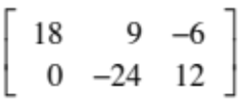 30. 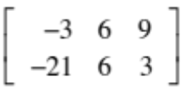 31. 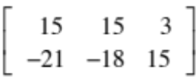
32. 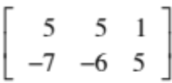 33. 34.
35. 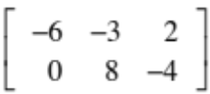 36. 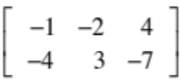 37-38. 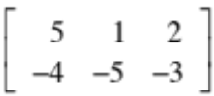
39-40. 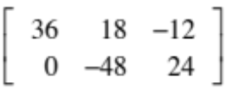 41. [ 6 10 ] 42. [ 6 10 ] 43. Impossible
44. a. 100 b. m.n c. 25 d. n2
45. a. 5, 5 b. a31 = 3 = a13, a32 = 6 = a23 c. 1, 4, 8
d. 2, -1, 6; 4, 5; 0
46. 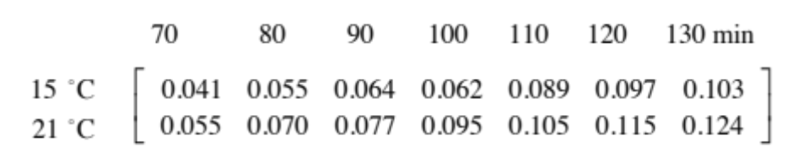
47. a. (0, 3, 2) b. (0.3, 0, 0) c. (0, 0.4, 0)
d. 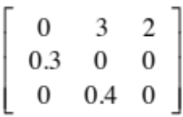 e. 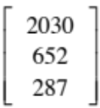 f. Lc = 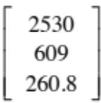
g. (Lc)c = 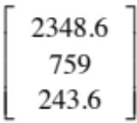 h. 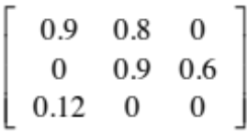 i. L²c =
j. equal
48. 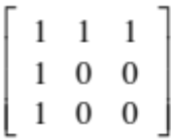 49. a. 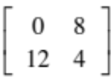 b. 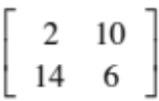
c. 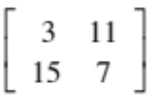 d. 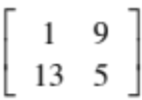
e. D₄ = 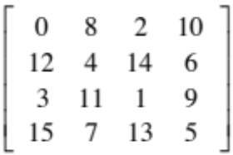 , V₄ = 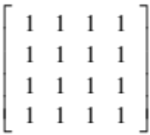
f. 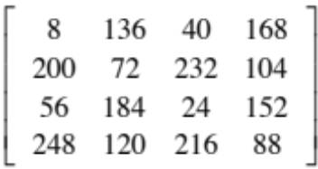 g. 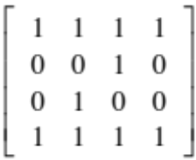 h. 1 -> black
50. 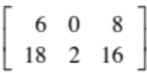 51. 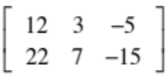 52. 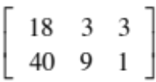
53. 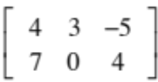 54. 55. Impossible
56. Impossible 57. 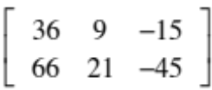 58. 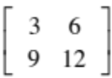
59. 60. 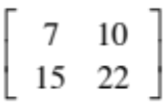 61. Impossible 62. 0_{2×2}
63. 0_{2×3} 64. 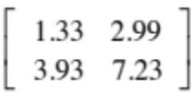 65. 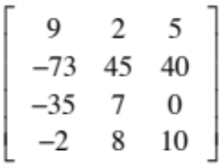
66. 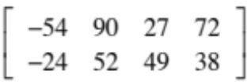 67. 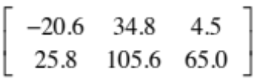 68. 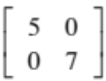
69. 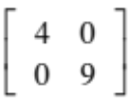 70. [9 16] 71. 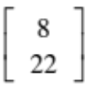 72. 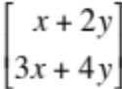
73. Impossible 74. Impossible 75. 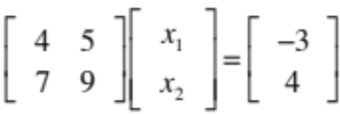
Module 13.3

1. a. Shrinking b. By 1.6% per year
c. 47.47%, 21.01%, 17.58%, and 13.94% because sum = -2.35 + -1.04 + -0.87 + -0.69 = -4.95 and (-2.35, -1.04, -0.87, -0.69)/-4.95 = (0.4747, 0.2101, 0.1758, 0.1394)
2. b. (2030, 652, 287)
3. b. 0.4583 dominant eigenvalue and the annual growth rate; decline
d. 1.3417 because the dominant eigenvalue of the Leslie matrix with
0.1 - 0.1(0.1) = 0.9(0.1) = 0.09 replacing 0.1 is 0.4449 and
(0.4449 - 0.4583) / (0.09 - 0.1) = 1.34
4. c. 32.53% = 0.3253 = 1 - 0.6747
d. 21.44% = 0.2144 = 1 - (0.7370 + 0.0486) because stage 2 turtles survive and remain at stage 2, survive and advance to stage 3, or die in any one year.
5. a. 0.1 is the probability that in one year a stage 1 animal survives and advances to stage 2. 0.2 is the probability that in one year a stage 2 animal survives and remains at stage 2. (Other descriptions are left to the reader.)
Module 13.4
1. a. 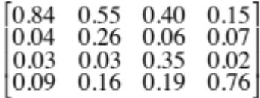
b. (0.25, 0.25, 0.25, 0.25)
2. a. 1 - 3α
b. 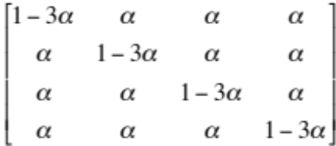
d. 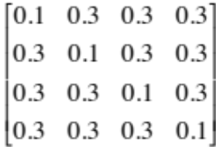
with (0.25, 0.25, 0.25, 0.25) ultimate distribution of bases
3. a. 1 - α - 2β

